
Anjali.V et al, / (IJCSIT) International Journal of Computer Science and Information Technologies, Vol. 7 (2) , 2016, 760-763

Web Based Placement Management System

Anjali.V #¹, Jeyalakshmi.PR^{*2}, Anbubala.R^{#3},Sri Mathura devi.G^{#4},Ranjini.V^{#5}

#Computer Science Department, Saranathan College of Engineering,
Venkateswara Nagar, Panjappur, Trichy-12.

Abstract— The project is aimed at developing an application for the “WEB BASED PLACEMENT MANAGEMENT SYSTEM” of the college. The system is an application that can be accessed and effectively used throughout the organization with proper login enabled. This system can be used as an application for the Placement Officers in the college to manage the student information with regard to placement. Student logging should be able to upload their personal and educational information in the form of a resume. The key feature of this project is that it is one time registration enabled. Our project provides the facility of maintaining the details of the students. It reduces the manual work and consumes less paper work to reduce the time. This project is developed with PHP for frontend and MY SQL for backend.

INTRODUCTION

be done manually. This is tedious and time consuming, lack of security of data, took more man power, consumes large volume of paper and space. This process is so difficult when number of user’s increases.

PROPOSED SYSTEM

The aim of the proposed system is to develop a system with improved facilities. The proposed system can overcome all the limitation of the existing system, such as student’s information is maintained in the database, it gives more security to data, ensures data accuracy, reduces paper work and save time, only eligible students get chance, it makes information flow efficient and paves way for easy report generation, reduce the space. proposed system is cost effective.

The purpose of the project “WEB BASED PLACEMENT MANAGEMENT SYSTEM”, the manual work makes the process slow and other problems such as inconsistency and ambiguity on operations. In order to avoid this web based placement managed system is proposed, where the student information in the college with regard to placement is managed efficiently. It intends to help fast in fast access procedures in placement related activities and ensures to maintain the details of the student. Students logging should be able to upload their personal and educational information. The key feature of this project is that it is one time registration enabled.

The placement cell calls the companies to select their students for jobs via the campus interview. The placement cell allows the companies to view the student resumes in selective manner. They can filter the students profile as per their requirement. The job details of the placed students will be provided by the administrator. The administrator plays an important role in our project. Our project provides the facility of maintaining the details of the students and gets the requested list of candidates for the company who would like to recruit the students based on given query.

SYSTEM ANALYSIS
PROBLEM DEFINITION
Students choose a specific college where the placement will be held, there is a need to maintain all these papers, causing large amount of space. It is manually done, chances of missing, difficult to handle the details of student.

EXISTING SYSTEM

The existing system describes the features of the previous working model and their drawback. Existing system does all process manually. Placement officers register the information of students. If any modifications or updates are required in the profile of any student, it has to

FEASIBILITY STUDY

The purpose of the feasibility study is not to solve the problem, but to determine the problem is worth solving. This helps to decide whether to proceed with the problem or not. It involves the analysis of the problem & collection of all relevant information relating to the product such as items that would be input to the system, processing required to carried those data, the output data required to be produced by the system as well the various constraints on the behavior of the system. "Web based placement management system” had undergone the feasibility study so that the proposed system is possible for development
deployment |  | in | our | college. | The feasibility study
concentrates |  | on | the | following, | such as Operational
Feasibility, Technical Feasibility, Economic Feasibility
A. | ECONOMIC FEASIBILITY
The economic feasibility study evaluate |  |  |  |  |  | the | cost
software | development |  |  | against the ultimate |  | income | or
benefits | get | from the developed system. There must |  |  |  |  | be
scope for profit after the success completion of the project.

B. TECHNICAL FEASIBILITY

Technical feasibility study compares the level of
technology available in the software development
firm and the level of technology required for the development of the product. The level of technology consists of the programming language, the hardware resources, other software tools etc.

- OPERATIONAL FEASIBILITY

Operational feasibility study tests the operational scope of the software to be developed. The proposed software must have high operational feasibility.The usability will be high.

www.ijcsit.com 760

Anjali.V et al, / (IJCSIT) International Journal of Computer Science and Information Technologies, Vol. 7 (2) , 2016, 760-763

SCOPE AND APPLICABILITY
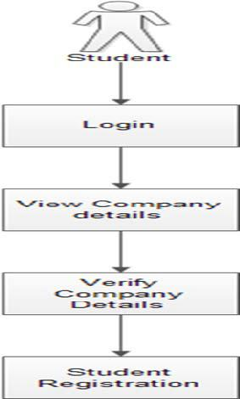
Scope:
Our project has a big scope to do. Students can access previous information about placement. We can stores information of all students. Various companies can access their information. Notifications are sent to students about the companies.

Applicability:

This project “Web based placement management system “is applicable for the companies and colleges.

SYSTEM ARCHITECTURE:


























Student Login:







Student Registration:
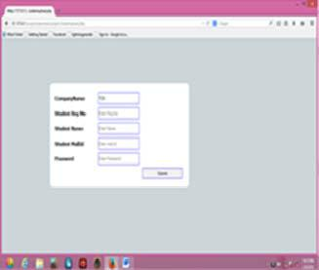

MODULE DESCRIPTION:

MODULES:
Online training and placement (OTAP) system provides the modules like

Student Admin Company

- STUDENT MODULE:

In this module, creation of student input records
about academic career from SSLC, HSC and all semester with facilities to modify the records and viewing changed records. The Student views the company details and verifies particular company details and provides valid details for registration.

www.ijcsit.com 761

Anjali.V et al, / (IJCSIT) International Journal of Computer Science and Information Technologies, Vol. 7 (2) , 2016, 760-763

B. COMPANY MODULE:

The company enrols themselves and they register their profile and their will marquee in the main page till their drive and view the student’s details and update their details. Login Company, registration, students details view
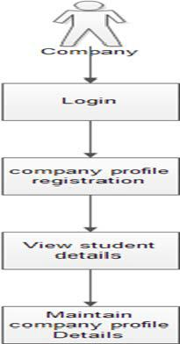

C. ADMIN MODULE

The admin is the placement officer who views the students details and company details and post the selected students list. Sending email to student for complete list of information for particular campus. Indication of hall ticket issued to candidates through mail. Login, View company details, View selected students details, Sending mail.
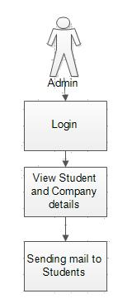

New Company Registration:
Admin Login:
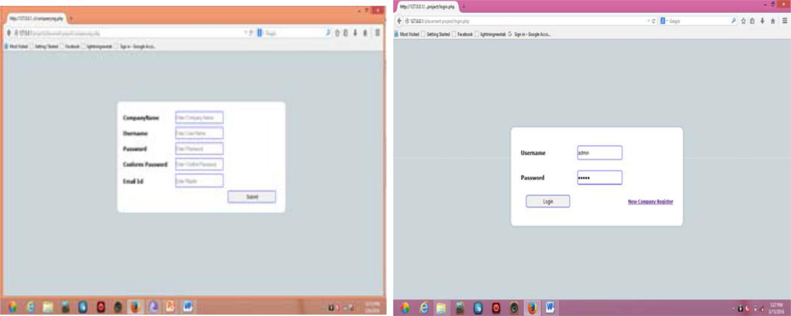

www.ijcsit.com 762

Anjali.V et al, / (IJCSIT) International Journal of Computer Science and Information Technologies, Vol. 7 (2) , 2016, 760-763

View Student details:
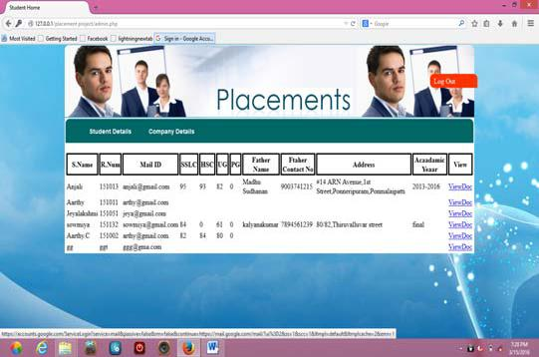

View Company details:
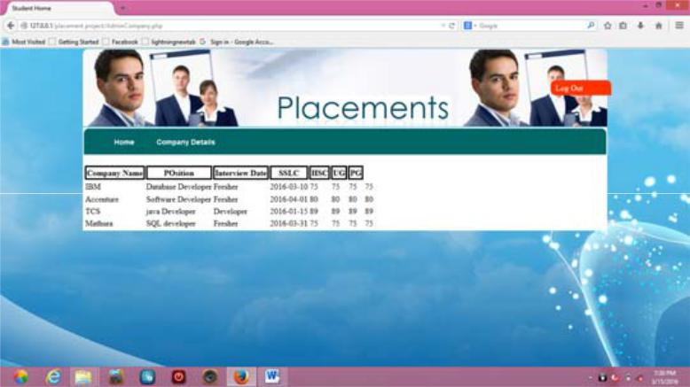

CONCLUSION:

The introduction, problem definition of the project has been completed successfully to college Web based placement management system by maintaining the student details related to placement in an efficient manner.

REFERENCES:

- Gunderloy, Jorden BPB Publications (2000) - “Mastering SQL Server”
- Luke Welling and Laura Thomson (5th Edition) - “PHP and MySQL Web Development”

- Roger S.Pressmen, T. Mc. GH. – Software Engineering (Theoretical Approach)
- Thereon Willis wrox publications (2000) - “Beginning SQL Server”

www.ijcsit.com 763

